**Tutorial – 3**

**1. Draw a real picture for class and object. Differentiate class and object in terms of diagram only.**

**Perform following tasks.**

| **using System; namespace _24SOECE13043_Dharmraj_sodha.LAB3 {  class Car  {  private string brand;  private string model;  private int price;  public Car(string b, string m, int p)  {  brand = b;  model = m;  price = p;  }  public void DisplayInfo()  {  Console.WriteLine("Brand: " + brand);  Console.WriteLine("Model: " + model);  Console.WriteLine("Price: " + price);  }  public void IncreasePrice(int amount)  {  price += amount;  Console.WriteLine("Price increased by " + amount);  }  }  class Demo  {  public static void Main(string[] args)  {  Car car1 = new Car("BMW", "X5", 7500000);  Car car2 = new Car("Tesla", "Model S", 8500000);  Console.WriteLine("\nCar 1 Info:");  car1.DisplayInfo();  car1.IncreasePrice(50000);  car1.DisplayInfo();  Console.WriteLine("\nCar 2 Info:");  car2.DisplayInfo();  car2.IncreasePrice(100000);  car2.DisplayInfo();  Console.ReadKey();  }  } }** |
| --- |

**Output :**

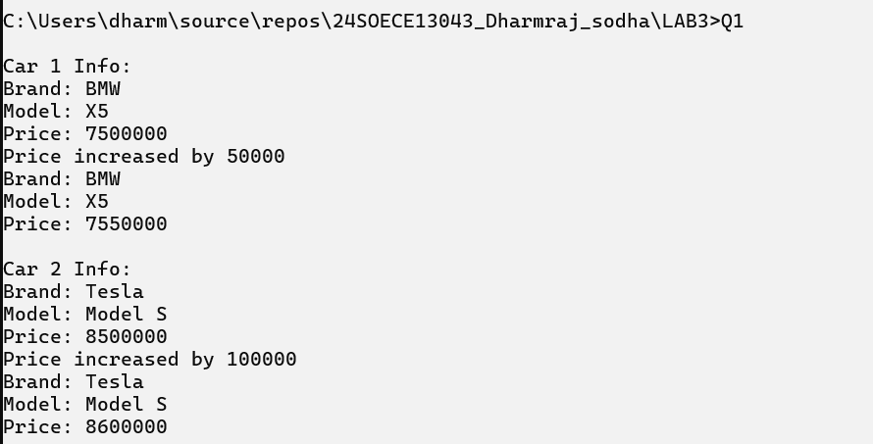

**2.Define a class Clock with three *private* integer data members hour, min and sec…**

| **using System;  namespace _24SOECE13043_Dharmraj_sodha.LAB3 {  class Clock  {  private int hour, min, sec;   public Clock()  {  hour = 12; min = 0; sec = 0;  }   public Clock(int h, int m, int s)  {  hour = h; min = m; sec = s;  }   public void Tick()  {  sec++;  if (sec == 60) { sec = 0; min++; }  if (min == 60) { min = 0; hour++; }  if (hour == 24) { hour = 0; }  }   public void Display()  {  Console.WriteLine($"{hour:D2}:{min:D2}:{sec:D2}");  }   public int getHour() => hour;  public int getMinute() => min;  public int getSeconds() => sec;  }   class TestClock  {  static void Main()  {  Clock c1 = new Clock();  Clock c2 = new Clock(10, 59, 58);   c1.Display();  c2.Display();   c2.Tick();  c2.Display();   Console.ReadKey();  }  } }** |
| --- |

**Output:**

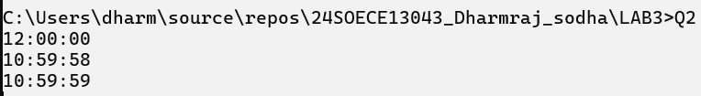

**3. Define a Student class with appropriate data members, property, constructors, methos etc….**

| **using System;  namespace _24SOECE13043_Dharmraj_sodha.LAB3 {  class Student  {  private int enrolmentNo;  private string name;  private int age;   public Student(int e, string n, int a)  {  enrolmentNo = e;  name = n;  age = a;  }   public void Display()  {  Console.WriteLine($"EnrolmentNo: {enrolmentNo}, Name: {name}, Age: {age}");  }  }  class TestStudent  {  public static void Main(string[] args)  {  Student s1 = new Student(101, "Aarav", 20);  s1.Display();   Console.ReadKey();  }  } }** |
| --- |

**output :**



**4.Use above program classes and create objects for 5 students and demonstrate the use student class.**

| **using System;  namespace _24SOECE13043_Dharmraj_sodha.LAB3 {  class Student  {  private int enrolmentNo;  private string name;  private int age;   public Student(int e, string n, int a)  {  enrolmentNo = e;  name = n;  age = a;  }   public void Display()  {  Console.WriteLine($"EnrolmentNo: {enrolmentNo}, Name: {name}, Age: {age}");  }  }   class TestStudent  {  public static void Main(string[] args)  {  Student s1 = new Student(101, "Aarav", 20);  Student s2 = new Student(102, "Meera", 21);  Student s3 = new Student(103, "Ravi", 22);  Student s4 = new Student(104, "Isha", 20);  Student s5 = new Student(105, "Dev", 23);   s1.Display();  s2.Display();  s3.Display();  s4.Display();  s5.Display();   Console.ReadKey();  }  } }** |
| --- |

**Output :**

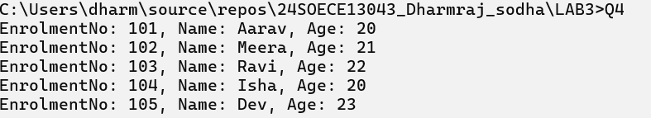

**5. Rearrange the given code to get the desired output.**

| **using System;  namespace _24SOECE13043_Dharmraj_sodha.LAB3 {  class Product  {  int pcode;  String pname, mname;   public Product(int pcd, String pnm, String mnm)  {  pcode = pcd;  pname = pnm;  mname = mnm;  }   public void Display()  {  Console.WriteLine("\nProduct Code:= " + pcode);  Console.WriteLine("\nProduct Name:= " + pname);  Console.WriteLine("\nManufacturer Name:= " + mname);  }  }   public class TestProduct  {  public static void Main(string[] args)  {  if (args.Length < 3)  {  Console.WriteLine("Syntax Error\n");  Console.WriteLine("Must Have THREE Arguments\n");  Console.WriteLine("Please, Write as [csc TestProduct ProductCode ProductName Manufacturer] \n");  }  else  {  int pcd = Convert.ToInt32(args[0]);  String pnm = args[1];  String mnm = args[2];   Product p = new Product(pcd, pnm, mnm);  p.Display();   Console.Read();  }  }  } }** |
| --- |

**Output :**

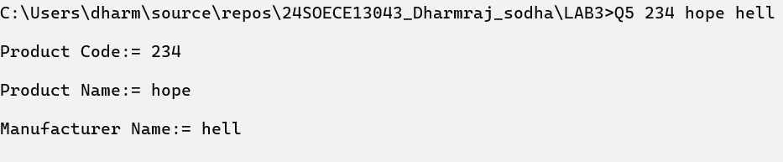

**6. Complete the following code that will generate the given output**

| **using System;  namespace _24SOECE13043_Dharmraj_sodha.LAB3 {  class Line  {  private double length;   public Line()  {  Console.WriteLine("Object is being created, length = 10");  length = 10;  }   public void setLength(double len)  {  length = len;  }   public double getLength()  {  return length;  }  }   class TestLine  {  static void Main(string[] args)  {  Line line = new Line();  Console.WriteLine("Length of line : {0}", line.getLength());   line.setLength(6);  Console.WriteLine("Length of line : {0}", line.getLength());   Console.ReadKey();  }  } }** |
| --- |

**Output :**

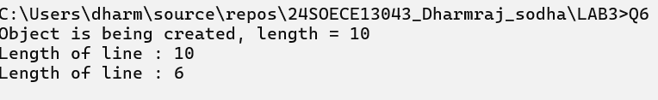

**7. Define EnrolmentNo and Name properties for the Student class and demonstrate use of these properties along with required data members, methods and constructors.**

| **using System;  namespace _24SOECE13043_Dharmraj_sodha.LAB3 {  class Student  {  private int enrolmentNo;  private string name;   public int EnrolmentNo  {  get { return enrolmentNo; }  set { enrolmentNo = value; }  }   public string Name  {  get { return name; }  set { name = value; }  }   public Student(int e, string n)  {  enrolmentNo = e;  name = n;  }   public void Display()  {  Console.WriteLine($"EnrolmentNo: {EnrolmentNo}, Name: {Name}");  }  }  class TestStudent  {  static void Main()  {  Student s1 = new Student(201, "Karan");  Student s2 = new Student(202, "Pooja");   Console.WriteLine("Before update:");  s1.Display();   s1.Name = "Karan Patel";   Console.WriteLine("After update:");  s1.Display();   s2.Display();  Console.ReadKey();  }  } }** |
| --- |

**Output:**

